Full Title: Population trends and entanglement rates of Steller (*Eumetopias jubatus*)and California (*Zalophus californianus*) sea lions on the north coast of Washington state

Short Title: Sea lion population trends and entanglements on the north coast of Washington state

Elizabeth Allyn and Jonathan Scordino

Makah Fisheries Management PO Box 115 Neah Bay, WA 98357

# Abstract

Entanglement impacts many marine species around the globe, and for some species of marine mammals, those impacts are great enough to cause population declines. Otariids specifically are often playful around new objects, putting them at risk of entanglement in many types of marine debris, including terrestrial and marine pollution and fishing gear. This study aimed to calculate the rates of population growth and to document the rates and causes of entanglement in Steller and California sea lions on the north coast of Washington state from 2010-2018. Counts of sea lions were conducted at haulouts along the survey area from small boats and photographs of entangled individuals were taken for later analysis to determine the nature of the entangling material and the sex and age of the entangled individual. Rates of entanglement and entangling material occurrence were compared with records collected from stranded individuals on the Washington and Oregon coast by the West Coast Marine Mammal Stranding Network and with packing bands recorded during beach debris surveys conducted by the Olympic Coast National Marine Sanctuary. During the study period, Steller sea lions exhibited a 7.9% ± 3.2 population growth rate, which was similar to that seen in California sea lions (7.8% ± 4.2). California sea lions experienced a much higher rate of entanglement than Steller sea lions (2.13% and 0.41%, respectively), though both rates are not likely to be causing population-level concern, evidenced by the large population growth rates in both species throughout the study period, they do still pose a significant welfare concern to the affected individuals. The majority of entangled individuals were adults (83.1%), 55.4% of which were male and 41.7% were female, 12.5% were juveniles, and no entangled pups were observed. Steller sea lion entanglements showed no seasonal patterns, but California sea lions experienced a peak in entanglement rates in June and July, with somewhat elevated entanglements also seen in November. The majority of identifiable entanglements were caused by packing bands (68.3%) year-round, followed by salmon flashers (11.3%), which only occurred in the summer months of May – September, coinciding with the peak of the local recreational and commercial ocean salmon troll fishery. The occurrence of packing bands in beach debris surveys correlated with the occurrence of entanglements caused by packing bands in sea lions observed on haulouts during survey effort (Pearson’s R=0.81). However, no sea lions entangled in packing bands were observed in the stranding record, and the overall proportion of stranded animals exhibiting evidence of entanglement was lower than expected, indicating that animals are likely shedding entangling materials at higher rates than are currently predicted. While large-scale government-instigated actions to address marine debris issues have had mixed success around the world, simple actions such as cutting packing bands may be the best option for reducing the impact of entanglement on local pinnipeds.

# Introduction

The prevalence of marine debris is of global concern and has been gaining attention from media, researchers, and the public in recent decades as the impact to marine life becomes better understood [1–5]. Many marine organisms are affected by marine debris through entanglement. Instances of entanglement have been recorded for at least 64 species of marine mammals globally [4], and for some, like the northern fur seal (*Callorhinus ursinus*) and the endangered Hawaiian monk seal (*Monachus schauinslandi*), entanglement was thought to have contributed to population declines [6,7]. For pinnipeds specifically, entanglement has been documented for more than half of the existing species [2,4,8]. In this study, entanglement is defined as the presence of marine debris attached to the body, including materials that are looped around the appendages or neck (e.g. netting or packing bands). We also included instances where materials are internally or externally embedded (e.g. hooks). Quantifying the effects of entanglement is a challenging undertaking, as affected individuals may spend more time at sea as a result of their greater energy expenditure or die at sea without being observed [4,8,9]. Even harder to detect are invisible entanglements, where an animal may swallow a hook and suffer internal damage as a result [10]. Any estimates of entanglement rates in a population therefore likely underestimate both the prevalence and potential impact of entanglement.

The mechanisms by which an animal becomes entangled are almost as varied as the entangling materials themselves. Any debris that forms loops or that contains a hook that can be swallowed or embedded poses an entanglement risk, including pollution from terrestrial and marine sources, and derelict and active fishing gear. The mechanism of entanglement can often be determined by identifying the entangling material. Packing bands, rubber bands, monofilament line, and netting fragments are likely encountered as debris, while salmon flashers and other hook and line gear are likely encountered as actively fished gear and are evidence of fishery depredation behaviors. Much of the debris that enters the marine environment is made of synthetic materials and either floats or is neutrally buoyant, increasing the odds that a marine mammal encounters it. Otariids are especially curious of new objects, and can become entangled in debris while attempting to explore or play with them [11,12]. While it seems they are occasionally able to shed entangling materials, the frequency and mechanisms with which animals are able to escape unharmed from entanglement are not well understood [11,12]. Individuals can also risk entanglement through depredation of fisheries, which puts them in direct contact with potentially entangling materials and can cause significant losses to fishers [13,14]. The factors leading to entanglement in any given location are therefore governed by both local and regional dynamics, as ocean currents, upwelling patterns, fishing effort and gear types used, prey distributions, abundance of pinnipeds, and marine traffic patterns all may contribute to both the distribution of entangling materials and the behavior of pinnipeds in the area [15–18].

The objective of this study was to characterize the rates and causes of entanglement in Steller (*Eumetopias jubatus*)and California (*Zalophus californianus*) sea lions in northern Washington state and to evaluate if the observed entanglements were negatively impacting the populations. This study also described temporal trends in entanglement occurrence and determined the most commonly observed entangling materials. Based on previous studies, we expected to see entanglements caused by mainly packing bands and netting [1,4,8,19–21]. We expected little change in annual entanglement occurrence but anticipated that there would be a peak in entanglements observed in the mid- to late-summer months due to these being the peak months for recreational and commercial fishing effort. Understanding the patterns behind entanglement occurrence will enable the development of more targeted prevention and response efforts and a more accurate understanding of the impacts of entanglement on local populations.

# Methods

## Data Collection

Observations of hauled out Steller and California sea lions were carried out from small boats along the north coast of Washington from 2010 –2018 focusing on four major haulout locations (Figure 1). Surveys were conducted year-round with more effort from late spring through early fall than in other months of the year due to availability of survey days with suitable weather and sea conditions. Surveys often did not include all haulouts during a day due to logistical challenges such as sea conditions, number and duration of sightings, and daylight. During surveys, we documented sightings of actively entangled individuals and individuals showing evidence of past entanglement (e.g. scarring) and counted the total abundance of the two sea lion species at each haulout. We attempted to photograph all entangled sea lions and those that appeared entangled for later assessment. Entangled individuals encountered along the survey route in locations other than the four major haulout sites were excluded from entanglement rate calculations due to the lack of reliable and regular total counts of hauled individuals, but they were still documented for inclusion in the analysis of entangling materials.

Fig 1: Map of the four major Steller and California sea lion haulout sites surveyed for entangled individuals: Tatoosh Island, the Bodelteh Islands, Carroll Island, and Sea Lion Rock.

## Population Trends

Population trends were calculated using a three-step process. First, for each species we pooled the counts from the four major haulouts on days when all four haulouts were visited. Next, we averaged all complete survey days within a month for a monthly average. Last, we averaged the average monthly counts for an annual estimate and a monthly estimate of average number of sea lions using the four major haulouts over the study duration for Steller and California sea lions. The observed change in annual counts were calculated for each year using the formula $\ln\left({N_{t+1}}/{N_{t}}\right)$, then averaged over all study years to produce the overall average population growth rate for each species (Figure 2). We excluded data from 2018 in the analysis because there were no survey days that covered all four haulout sites after June, potentially biasing the counts by not including the full range of seasonal variation (Table 1).

Table 1: The number of surveys conducted in each month of the study period 2010-2018 with the number of complete surveys where all four major haulouts locations were visited in parentheses. Note that no complete surveys were conducted after June in 2018.

|  |  |  |  |  |  |  |  |  |  |  |  |  |  |
| --- | --- | --- | --- | --- | --- | --- | --- | --- | --- | --- | --- | --- | --- |
|  | **1** | **2** | **3** | **4** | **5** | **6** | **7** | **8** | **9** | **10** | **11** | **12** | **Total** |
| 2010 |  | 1 | 1 | 1 | 3(1) | 2 | 3(1) | 5(3) | 8(2) | 2 | 2(1) |  | 28(8) |
| 2011 | 1 | 2(1) | 2 | 4(1) | 6(3) | 5(2) | 4(2) | 6(2) | 3(2) | 4(1) | 3(1) |  | 40(15) |
| 2012 |  | 2 | 2(1) | 2(1) | 3(2) | 5(4) | 8(1) | 4(2) | 5(2) | 2(1) | 3(1) | 2(1) | 38(16) |
| 2013 | 2(1) | 1(1) | 2(1) | 2(1) | 3(1) | 4(3) | 3(2) | 3(2) | 3(1) | 3 | 2 |  | 28(13) |
| 2014 |  |  |  | 2 | 2(1) | 3(2) | 4(2) | 4(1) | 4(3) | 2 |  |  | 21(9) |
| 2015 | 3(2) | 2(1) | 1 | 3 | 2 | 2 | 4(1) | 5(2) | 4(1) | 1 | 1 |  | 28(7) |
| 2016 | 1(1) |  | 4 | 1 | 5(3) | 1(1) | 4(2) | 4(2) | 3(3) | 3(1) |  | 1(1) | 27(14) |
| 2017 | 1(1) | 2(1) | 1 |  |  | 3(3) | 1 | 4(3) | 3(1) | 1(1) |  |  | 16(10) |
| 2018 |  | 1 | 3(1) | 2(1) | 1(1) | 3(2) | 3 | 3 | 3 | 1 |  |  | 20(5) |
| **Total** | **8(5)** | **11(4)** | **16(3)** | **17(4)** | **25(12)** | **28(17)** | **34(11)** | **38(17)** | **36(15)** | **19(4)** | **11(3)** | **3(2)** | **246(97)** |

## Entanglement Rates

Our goal was to calculate an average annual entanglement rate for California and Steller sea lions for the northern Washington coast. Entanglement rates were calculated using the counts of the total number of individuals observed during surveys of the four main haulout sites and the counts of entangled individuals, including both active and inactive entanglements, taken from photographs and survey notes. Our survey effort was greatest during the summer and early fall when sea conditions were most predictable. In order to ensure that our calculated entanglement rate was representative of the year, and not biased to time periods when we had more surveys, we calculated average yearly entanglement rates using a multistep process (Figure 1). Counts of the total number of individuals hauled out and counts of entangled individuals were pooled across haulout sites within survey days, and an entanglement rate was calculated for each survey day by dividing the total number of entangled individuals by the total count. Average entanglement rates were then calculated for each month of the nine-year study period. The average rates for each month of the study were then averaged over the months or years of the study period to discern seasonal and annual patterns. An overall average entanglement rate was calculated for each species by taking the average of the monthly average entanglement rates (Figure 2).

## Photo Analysis

We assessed photographs of entangled individuals to determine if the entanglement was active or inactive, identify the entangling material, and record the age and sex of the entangled individual. Entangled individuals were assigned to demographic groups by age as adult, juvenile, pup, or unknown, and by sex for adults based on size and shape, whisker length, and presence of secondary sexual features. The proportion of entangled individuals in each sex and age class were calculated. Entangling materials were identified to the greatest possible specificity, but generally fell into one of nine categories: packing band, salmon flasher, rubber band, monofilament line, hook and line, netting, rope, scar, or unknown. Salmon flashers are plastic or metal attractants attached to a line normally 60 to 100cm before the lure or baited hook, which is often swallowed, leaving the flasher to dangle out of the mouth. The hook and line category includes fishing lures and longline gear, both of which are found hooked externally on the entangled individual or hooked around the mouth. Rubber bands are thick black bands cut from truck tire inner tubes that are often used in crab fisheries to secure trap doors. The netting category includes both gillnet and trawl netting. Any active entanglement where the material could not be identified was recorded as unknown. Animals with evidence of a previous, currently inactive entanglement were recorded as scar. The proportion of entanglements exhibiting each entangling material were calculated over months and years to analyze trends in material occurrence.

## Packing Band Analysis

Annual packing band entanglement occurrence was further analyzed for correlation with data from marine debris surveys conducted by the Olympic Coast National Marine Sanctuary (OCNMS) to discern patterns in material availability in the environment. The year 2018 was excluded from analysis of annual trends due to low survey effort after the month of June. OCNMS conducted 1,548 monthly beach debris surveys in the Olympic Coast region from 2012-2017, covering 17 beaches in Washington State, from Roosevelt Beach (47.1770**°** N, 124.1972**°** W) to Wa’atch Beach (48.3441**°** N, 124.6792**°** W). Surveys were conducted by volunteers adhering to standardized debris monitoring procedures developed by NOAA’s Marine Debris Program [22]. The number of packing bands encountered each year in beach debris surveys was divided by the total number of surveys conducted in that year to correct for variation in survey effort.

## Stranding Analysis

Opportunistic sightings of stranded animals have been recorded by the West Coast Marine Mammal Stranding Network, overseen by the West Coast Regional Office of NOAA’s Protected Resources Division, since the early 1980’s. Data on Steller and California sea lions that stranded dead on the Washington and Oregon coast from 2010-2018 were analyzed to determine the occurrence of evidence of entanglement on stranded individuals. Entanglements were assigned to three categories depending on the nature of the entanglement evidence: animals that stranded with the entangling material still present were marked as “Active”, animals with evidence of lesions or other entanglement-related injuries but no entangling material present were marked “Scar”, and animals showing possible but inconclusive evidence of entanglement were marked “Possible”. For active entanglements, the entangling material was determined using notes and comments accompanying the stranding record according to the same material categories used to categorize the entangled individuals observed live on haulouts. Entanglements marked “Possible” were excluded from summary statistics due to inconsistencies in reporting suspicious lesions as potential entanglement evidence.

# Results

## Population Trends

There were 189 survey days from 2010-2017 where counts were recorded at all four major haulouts. The average annual population growth of Steller sea lions in northern Washington was 7.9% ± 3.2 (95% CI), and California sea lions exhibited a similar average annual rate of change, 7.8% ± 4.2 (95% CI; Figure 2).

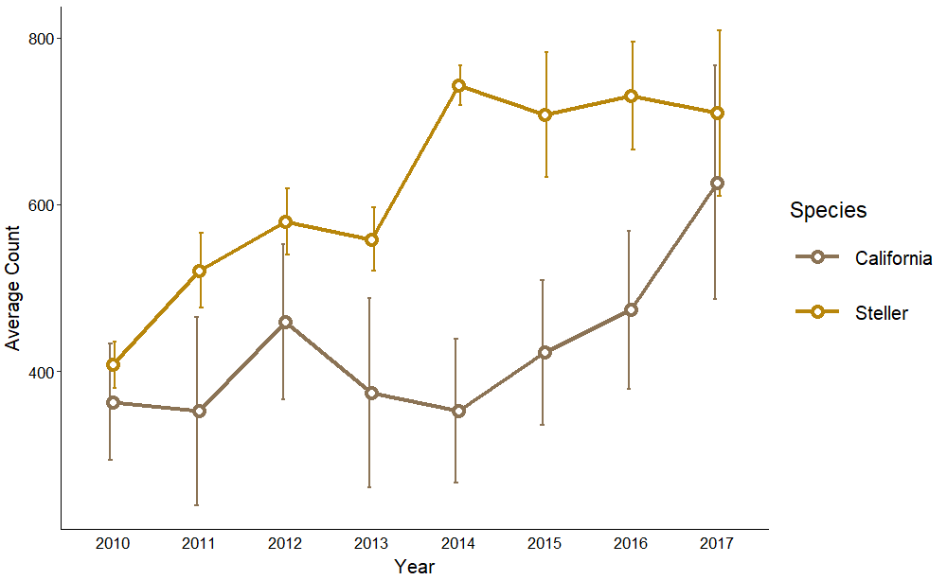

Fig 3: Trends in average annual counts of Steller and California sea lions present at four major haulouts on the north coast of Washington from 2010-2017

## Entanglement Rates

There were 648 active and inactive entanglements observed in the survey area from 2010-2018, 605 of which were documented at the four major haulout sites. Averaged over the entire study, the entanglement rate for California sea lions (2.13%) was greater than for Steller sea lions (0.41%), but the difference was not statistically significant (t-test, df = 11, p = 0.19). There were no annual or seasonal trends of statistical significance in entanglement rates for Steller sea lions, but California sea lions exhibited a peak in entanglement rate in the summer (Figure 3). The average entanglement rate for California sea lions in July (12.1%) was significantly greater than all other months (Single-Factor ANOVA, df = 11, p = 0.00047), except for June (10.2%; t-test, df = 14, p = 0.63) and November (1.5%; t-test, df = 9, p = 0.063), which also exhibited relatively high entanglement rates.

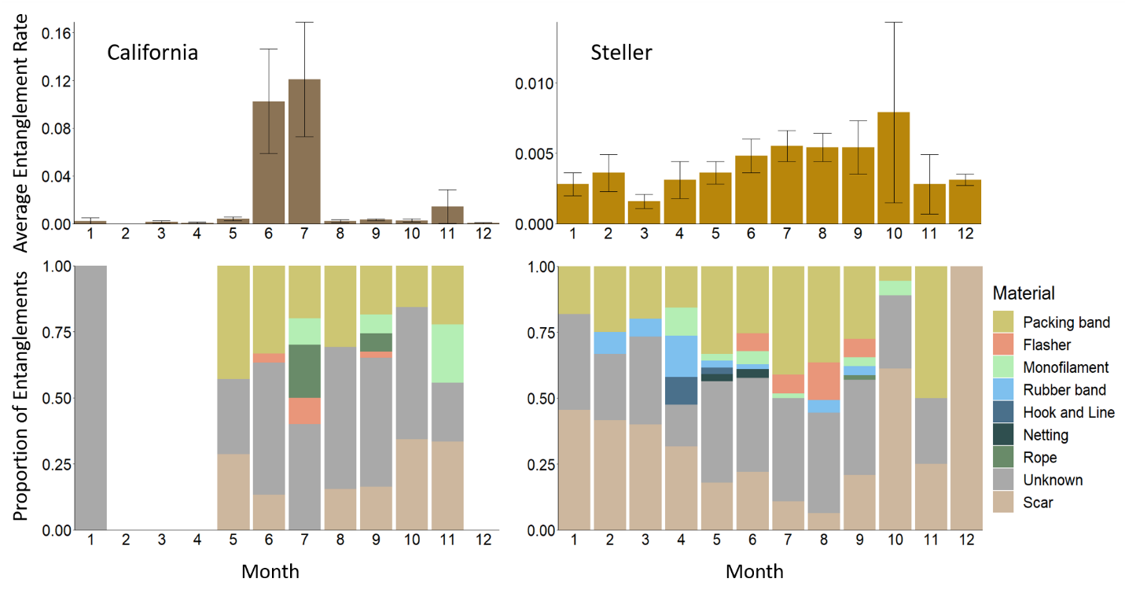

Fig 4: Average entanglement rates (expressed as entanglements per individual) and entangling material proportions for Steller and California sea lions in northern Washington from 2010-2018 by month. Entanglement rate calculations only included entangled individuals observed at one of four major haulout sites. Entangling materials were analyzed for any entangled individuals with photos of sufficient quality.

## Material Analysis

There were 502 sightings of entanglements with photos of a quality sufficient for analysis. Active entanglements comprised 78.5% of all entanglements, but the entangling material was only identifiable for 48.7% (n = 202) of them. The majority of identifiable entanglements were caused by packing bands (68.3%), followed by salmon flashers (11.8%), which were only observed in the months of May – September coinciding with the local recreational and commercial ocean salmon troll fishery (Figure 3). Other materials comprising less than 10% of identifiable entanglements were monofilament line (7.9%), rubber bands (5.9%), rope (2.9%), netting (1.5%), and hook and line (1.5%). In all cases where the entangling material could not be identified, the entanglement scar or wound was located on the neck, indicating that those entanglements were caused by an encircling material, such as a packing band, rubber band, monofilament line, or netting.

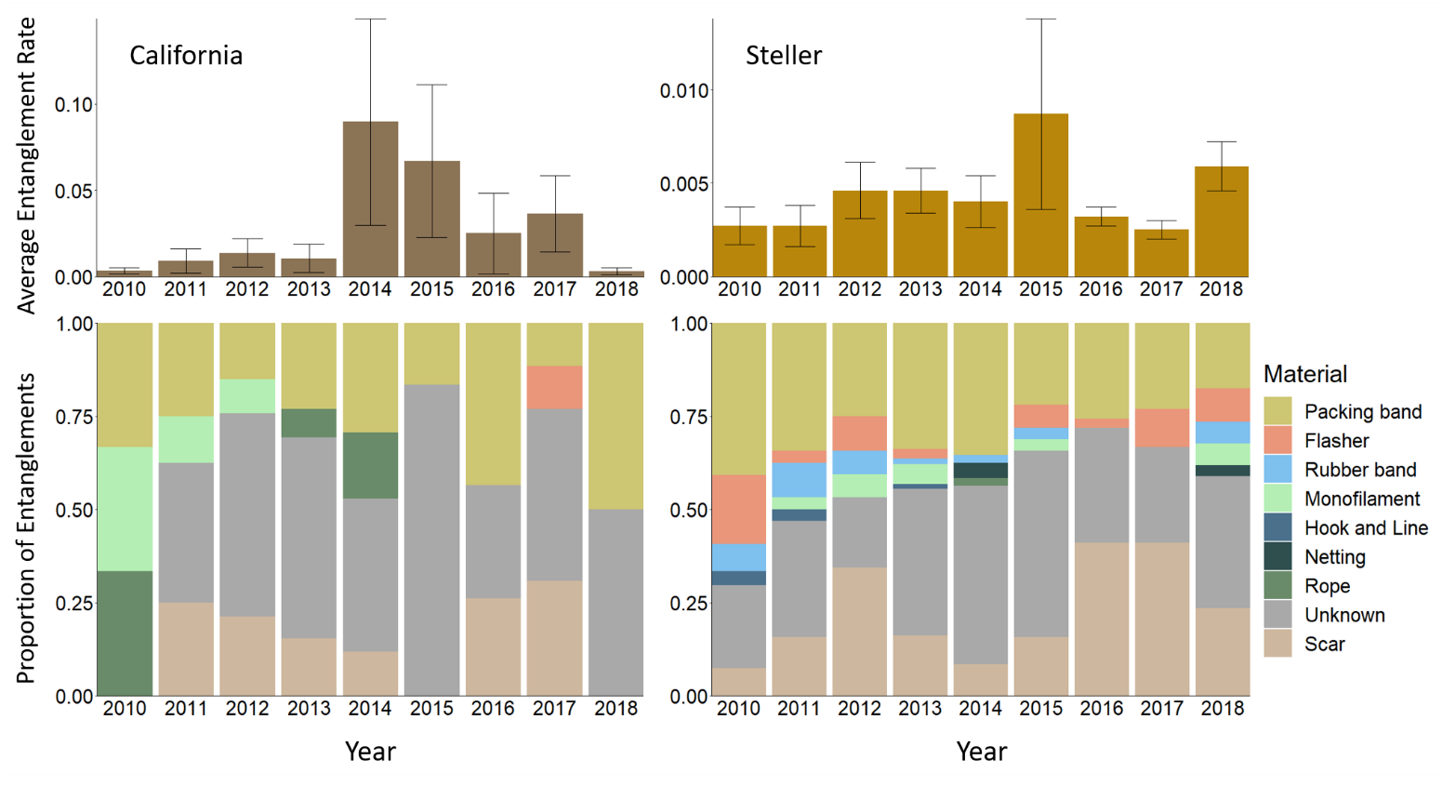

Fig 5: Average entanglement rates (expressed as entanglements per individual) and entangling material proportions for California and Steller sea lions in northern Washington from 2010-2018 by year. Entanglement rate calculations only included entangled individuals observed at one of four major haulout sites. Entangling materials were only analyzed for individuals with photos of sufficient quality.

## Sex and Age

The sex and age of the individual could be identified for 81.5% of entanglements, and either the sex or the age could be identified for an additional 14.3%. The majority of the entangled individuals were adults (83.1%), 55.4% of which were male and 41.7% were female, 12.5% were juveniles, and no entangled pups were observed. For the most part, entangling materials were evenly distributed among sex and age classes, but 15.9% of entangled juveniles exhibited a flasher and 11.1% exhibited rubber bands, much higher percentages than any other sex or age class grouping.

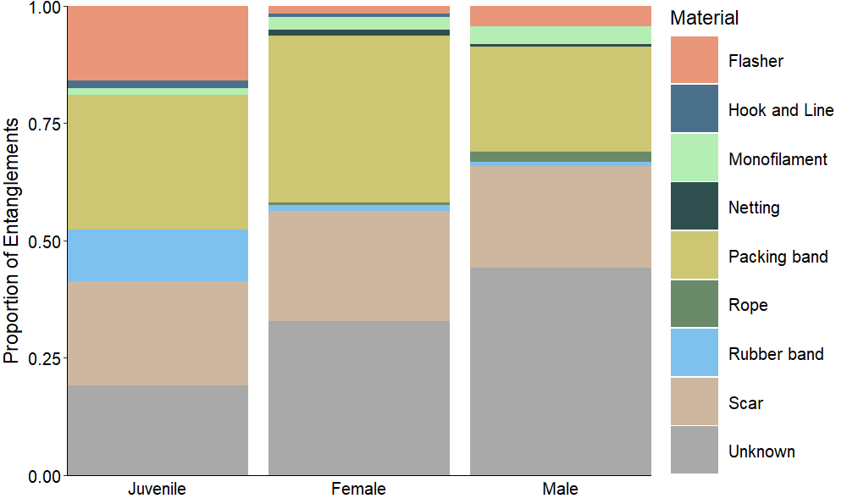

Fig 6: The proportion of entanglements caused by each material type for Steller and California sea lion juveniles, adult females, and adult males in northern Washington, 2010-2018.

## Packing Band Analysis

Annual trends in the proportion of entanglements caused by packing bands from 2012-2017 correlate with the annual occurrence of packing bands observed during OCNMS beach debris surveys after correction for survey effort (Pearson’s R=0.81; Figure 6).

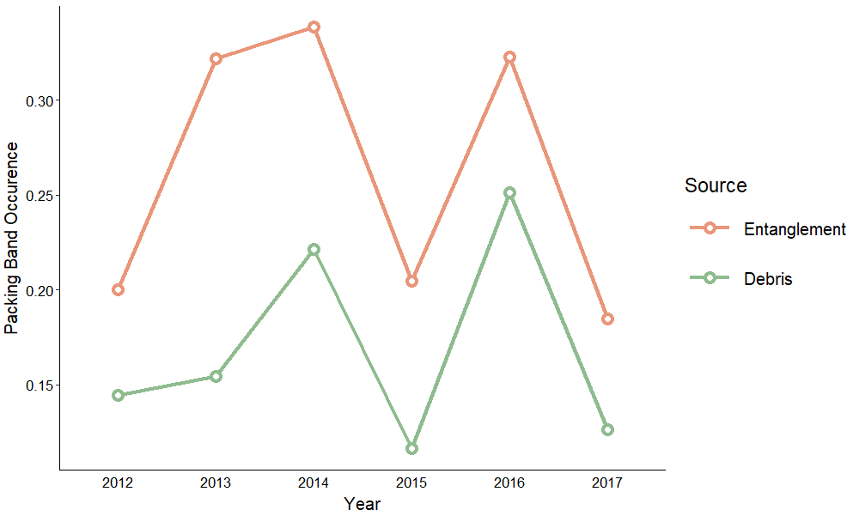

Fig 7: The proportion of entanglements caused by packing bands for sea lions at haulouts in northern Washington and the number of packing bands per survey recorded in beach debris surveys along the north Pacific coast of Washington conducted by the Olympic Coast National Marine Sanctuary

## Stranding Analysis

There were confirmed stranding records of 551 dead Steller sea lions and 1,048 dead California sea lions on the coast of Washington and Oregon from 2010-2018. The proportion of dead strandings exhibiting evidence of entanglement was 0.91% for Steller sea lions and 0.19% for California sea lions. The majority were entangled in salmon flashers and other assorted hook and line gear. There was also a single Steller sea lion entangled in rope, and another exhibiting scars indicative of entanglement. No sea lions stranded dead were observed entangled in packing bands.

# Discussion

The entanglement rate observed for California sea lions in this study was the second highest rate documented for any pinniped in the published literature and the highest pinniped entanglement rate documented in the United States (Harcourt, Aurioles, & Sanchez, 1994; S1 Table). The entanglement rate observed in this study for Steller sea lions was almost double other published rates [19,23]. Despite exhibiting high rates of entanglement, populations of both California sea lions and Steller sea lions exhibited high rates of growth in northern Washington, suggesting that entanglements did not meaningfully affect the population dynamics of either species in this area.

In the stranding record for the Washington and Oregon coast only seven California and Steller sea lions were found dead with signs of entanglement from 2010-2018. However, the proportion of dead stranded animals that exhibit evidence of entanglement is similar to the proportion of live sea lions observed with signs of entanglement from survey effort. Since dead stranded animals are a subset of the mortality experienced by a population, it is logical that if entanglement was a significant cause of mortality, the proportion of dead individuals with evidence of entanglement would be greater than for the live population at large. That this was not true is an indicator that recorded mortality due to entanglement was lower than expected. There are also very few records of dead stranded animals with clear evidence of entanglement in the literature [20,24]. There are two possible explanations for the lack of recorded mortalities from entanglement. The first is that entanglement has a much smaller effect on the health of the affected animals than is assumed. There are a few records of animals shedding entangling materials, including an adult female Antarctic fur seal (*Arctocephalus gazella)* that removed a tied loop of rope [25], a female monk seal with nursing pup who freed herself from a tangle of monofilament and polypropylene line [26], a large territorial Steller bull who shed two salmon flashers (pers comm. Justin Jenniges), and multiple monk seals who seemed to entangle and disentangle themselves in beached netting [24]. There is also a large proportion of animals in our entanglement record exhibiting entanglement-related scarring (21.5%), further indicating that entanglement is not always fatal. The second possibility is that entangled animals are dying at sea or otherwise away from areas where they might be detected, and more dedicated survey efforts would be required to track the survivorship of entangled individuals. Likewise, animals entangled in derelict fishing gear are unlikely to be discovered until the gear is recovered, so the impact of these unrecorded entanglement mortalities is likely underestimated [27]. Records of three entangled female California sea lions successfully weaning pups in Los Islotes, Baja California [17] further demonstrates that the impacts of entanglement on all aspects of pinniped population dynamics are poorly understood.

There are potential differences in the outcome of an entanglement depending on the entangling material. Packing bands were the most common entangling material in all study years for both species from live observations, similar to what was seen in other studies in the North Pacific [19,21,28]. However, not a single sea lion stranded dead on the Washington or Oregon coast from 2010-2018 entangled in a packing band. This could indicate that sea lions are able to shed packing bands at a higher rate than other materials. Flashers, on the other hand, made up 25% of strandings where the entangling material was identifiable, a much higher proportion than what was seen in live observations, indicating that individuals with entanglements caused by a swallowed hook could have a higher mortality rate. The presence of flasher entanglements only during May – September reinforces that sea lions either quickly shed the gear or die. Most sea lions were in good body condition when observed, suggesting it is more likely that they quickly shed the gear, though it is likely that some animals retain the hook after losing the visible flasher. Three animals in the Oregon stranding record had hooks in their stomach and esophagus, but no external signs of entanglement. One individual was found with a hook in the stomach and the attached flasher wedged in the esophagus, further demonstrating that animals impacted by embedded hooks may have sustained severe injuries without showing any observable evidence of entanglement until necropsy.

The age, size, and foraging experience of the sea lion may also impact the materials they become entangled in. The high proportion of entangled juveniles exhibiting flashers and rubber bands may be a function of their age: rubber bands may be too small to entangle a large adult male or female, and flasher entanglement is a sign of risky foraging behaviors of depredating salmon troll fisheries. The small number of unidentifiable entangling materials on juveniles may be because of their smaller size, which causes the material to sit on the surface of the skin where it can be easily identified. This may also explain the large number of unidentifiable entangling materials on adult males, whose considerable seasonal growth [29] could have caused entanglements to bury deep into the flesh where they are not readily observed. The Washington and Oregon stranding record also contains a larger proportion of adult males stranded dead with signs of entanglement than adult females or juveniles, though the sample size is too small to be definitive.

There is no clear annual trend in entanglement rates for either species, though there are a few interesting years worth noting. In 2014, California sea lions experienced elevated rates of entanglement, a larger proportion of which were caused by rope, and in 2015, both species experienced elevated rates of entanglement (Figure 5). 2014 - 2016 were also years of elevated large whale entanglements, raising the possibility that entanglements in sea lions and whales could be caused by similar conditions [18,30]. Other studies have shown that warm anomaly ocean conditions, usually associated with an El Niño event, can cause changes to the distribution of marine debris, fishing effort, and pinniped prey items, all of which can impact rates of entanglement [15,16,31]. In summer 2014, high sea surface temperatures associated with the warm anomaly referred to as “the Blob” reached the coast, causing the shortest upwelling season for the northern California Current on record [32], the impacts of which were seen well into 2016 [33]. It is possible that these anomalous ocean conditions changed the distribution of fishing effort and prey items important to whales and pinnipeds, contributing to the high levels of entanglement seen for both taxa.

While entanglement may not cause population-level concerns in Steller or California sea lions in Washington, it is still a significant welfare issue, especially considering that most entanglements are caused by humans, either through the creation of marine debris or through direct fishery interactions (except for animals collared by penguin skins [25,34]). The good news is that human-caused entanglements can be addressed through changes in human behavior. For entanglements caused by actively fished gear, outreach and education paired with deterrence strategies may prove effective, while marine debris requires tackling pollution sources or redesigning offending materials. In Kaikoura, New Zealand and South Georgia, campaigns to encourage fishermen to cut packing bands before disposal led to declines in packing band entanglements [17,35]. However, in Australia, large-scale efforts by the government and local fishermen to reduce entanglement failed to prevent entanglement rates from continuing to increase [36]. Page et al. proposed that the debris could originate from areas outside of Australian waters and away from local fishing grounds, making national legislation ineffective at addressing the trans-boundary issue. A similar situation could complicate entanglement prevention efforts in northern Washington because of the close proximity to the Canadian border and the presence of large basin-wide currents just offshore. Page et al. also commented on the ineffectiveness of redesigned materials meant to prevent entanglement risk, such as biodegradable packing bands, without mandating the use of those products. Similarly, while deterrents exist or are in development for various types of gear that could prevent animals from interacting with actively fished gear [37,38], it can be a challenge to find a solution that balances effectiveness with potential harm to the ecosystem [39–41]. While preventing entanglements altogether is likely an impossible task, small actions such as encouraging fishers to cut packing bands could decrease the impact on welfare of local pinniped species.

S1 Table: Pinniped entanglement rates in the published literature in ascending order

|  |  |  |  |  |  |  |
| --- | --- | --- | --- | --- | --- | --- |
| Year | Reference | Location | Region | Species | Dominant material | Rate |
| 1989 | [21] | Channel Islands | CA | Cu | NA | 0* |
| 2003 | [1] | Point Reyes | CA | Zc | NA | 0.03 |
| 1983 | [42] | St Paul Island | AK | Cu | NA | 0.04 |
| 1999 | [34] | Bouvetøya | Antarctica | Ag | Packing band | 0.024-0.059 |
| 1985 | [43] | Northwest Hawaiian Islands | HI | Ms | Netting | 0.06 |
| 1985 | [23] | Aleutians | AK | Ej | Netting | 0.07 |
| 1978 | [44] | Cape Cross general area | South Africa | Ag | NA | 0.11 |
| 1993 | [45] | Marion Island | Australia | Ag & At | Packing band | 0.15 |
| 2006 | [28] | St Paul Island | AK | Cu | Packing band | 0.17 |
| 1983 | [21] | Channel Islands | CA | Zc | Gillnet | 0.18 |
| 2005 | [28] | St Paul Island | AK | Cu | Packing band | 0.18 |
| 1994 | [36] | Kangaroo Island | Australia | Nc | Gillnet | 0.2 |
| 1989 | [21] | Channel Islands | CA | Zc | Gillnet | 0.22 |
| 1983 | [21] | Channel Islands | CA | Ma | Packing band | 0.24 |
| 1985 | [21] | Channel Islands | CA | Cu | NA | 0.24 |
| 1998 | [45] | Marion Island | Australia | Ag & At | Packing band | 0.24 |
| 2004 | [19] | SEAK and NBC | AK | Ej | Packing band | 0.26 |
| 1985 | [21] | Channel Islands | CA | Zc | Gillnet | 0.27 |
| 1987 | [21] | Channel Islands | CA | Zc | Gillnet | 0.27 |
| 1987 | [21] | Channel Islands | CA | Ma | Packing band | 0.28 |
| 1989 | [21] | Channel Islands | CA | Ma | Packing band | 0.28 |
| 1987 | [21] | Channel Islands | CA | Cu | NA | 0.28 |
| 1985 | [21] | Channel Islands | CA | Ma | Packing band | 0.36 |
| 1983 | [42] | St Paul Island | AK | Cu | Netting | 0.4 |
| 1988 | [46] | Bird Island | South Georgia | Ag | Packing band | 0.4 |
| 1994 | [36] | Kangaroo Island | Australia | Af | Packing band | 0.4 |
| 2004 | Unpub | Northwest Washington Coast | WA | Ej | Packing band | 0.43+ |
| 1988 | [43] | Northwest Hawaiian Islands | HI | Ms | Netting | 0.48 |
| 1993 | [31] | central-northern Gulf of California | Mexico | Zc | Netting | 0.49 |
| 1978 | [44] | Cape Cross | South Africa | Ag | Monofilament | 0.6 |
| 1990 | [7] | Northwest Hawaiian Islands | HI | Ms | Netting | 0.7 |
| 1975 | [42] | St Paul Island | AK | Cu | Netting | 0.71* |
| 2001 | [36] | Kangaroo Island | Australia | Af | Packing band | 0.9 |
| 2001 | [36] | Kangaroo Island | Australia | Nc | Gillnet | 1 |
| 2002 | [36] | Kangaroo Island | Australia | Nc | Gillnet | 1.3 |
| 1990 | [47] | Bass Strait | Tasmania | Af | Netting | 1.9 |
| 2000 | [48] | Kaikoura | New Zealand | Af | Netting | 0.6-2.84 |
| 2020 | This study | Northwest Washington Coast | WA | Zc | Packing band | 2.86+ |
| 1992 | [17] | Los Islotes | Mexico | Zc | Netting | 3.9-7.9 |

* Not a representative value, included for comparison.

+ Entanglement rate from this study

# Acknowledgements

Survey effort was conducted under permit….? The authors would like to acknowledge all the individuals who assisted with data collection, including Jeff Harris, Patrick Gearin, ??? from NOAA, and past technicians for the Makah Tribe, including Adrianne Akmajian, Maria Roberts…??

# References

1. Moore E, Lyday S, Roletto J, Litle K, Parrish JK, Nevins H, et al. Entanglements of marine mammals and seabirds in central California and the north-west coast of the United States 2001–2005. Mar Pollut Bull. 2009;58: 1045–1051. doi:10.1016/j.marpolbul.2009.02.006

2. National Oceanic and Atmospheric Administration. 2014 Report on the Entanglement of Marine Species in Marine Debris with an Emphasis on Species in the United States. Silver Spring, MD; 2014.

3. Dau BK, Gilardi KVK, Gulland FM, Higgins A, Holcomb JB, Leger JS, et al. Fishing gear-related injury in California marine wildlife. J Wildl Dis. 2009;45: 355–362. doi:10.7589/0090-3558-45.2.355

4. Laist DW. Impacts of Marine Debris: Entanglement of Marine Life in Marine Debris Including a Comprehensive List of Species with Entanglement and Ingestion Records. Coe J, Rogers D, editors. New York: Springer; 1997. doi:10.1007/978-1-4613-8486-1

5. Hofman RJ. The changing focus of marine mammal conservation. Trends Ecol Evol. 1995;10: 462–465. doi:10.1016/S0169-5347(00)89184-3

6. Fowler C. Marine debris and northern fur seals: a case study. Mar Pollut Bull. 1987;18: 326–335. doi:10.1016/S0025-326X(87)80020-6

7. Henderson JR. A pre- and post-MARPOL annex V summary of Hawaiian monk seal entanglements and marine debris accumulation in the Northwestern Hawaiian Islands, 1982-1998. Mar Pollut Bull. 2001;42: 584–589. doi:10.1016/S0025-326X(00)00204-6

8. Fowler CW. A review of seal and sea lion entanglement in marine debris. Proc North Pacific Rim Fish Conf Mar Debris 1987. 1988; 16–63.

9. Feldkamp SD, Costa DP, G.K. D. Energetic and behavioral effects of net entanglement on juvenile northern fur seals. Fish Bull. 1989;87: 85–94.

10. Franco-Trecu V, Drago M, Katz H, Machín E, Marín Y. With the noose around the neck: Marine debris entangling otariid species. Environ Pollut. 2017;220: 985–989. doi:10.1016/j.envpol.2016.11.057

11. Yoshida K, Baba N. The problem with fur seal entanglement in marine debris. In: Shomura RS., Yoshida HO, editors. Proceedings of the workshop on the fate and impact of marine debris, 27-29 November, 1984, Honolulu, HI, US. 1985. pp. 448–452.

12. Cawthorn MW. Entanglement in, and Ingestion of, Plastic Litter in Marine Mammals, Sharks, and Turtles in New Zealand Waters. Proceedings of the workshop on the fate and impact of marine debris, 27-29 November, 1984, Honolulu, HI, US. 1985.

13. Read AJ. The looming crisis: interactions between marine mammals and fisheries. J Mammal. 2008;89: 541–548. doi:10.1644/07-mamm-s-315r1.1

14. Weise MJ, Harvey JT. Impact of the California sea lion (Zalophus californianus) on salmon fisheries in Monterey Bay, California. Fish Bull. 2005;103: 685–696.

15. Donohue MJ, Foley DG. Remote sensing reveals links among the endangered Hawaiian monk seal, marine debris, and El Niño. Mar Mammal Sci. 2007;23: 468–473. doi:10.1111/j.1748-7692.2007.00114.x

16. Keledjian AJ, Mesnick S. The impacts of el niño conditions on california sea lion (*Zalophus californianus*) fisheries interactions: Predicting spatial and temporal hotspots along the california coast. Aquat Mamm. 2013;39: 221–232. doi:10.1578/AM.39.3.2013.221

17. Harcourt R, Aurioles D, Sanchez J. Entanglement of California sea lions at Los Islotes, Baja California Sur, Mexico. Mar Mammal Sci. 1994;10: 122–125. doi:10.1111/j.1748-7692.1994.tb00399.x

18. Santora JA, Mantua NJ, Schroeder ID, Field JC, Hazen EL, Bograd SJ, et al. Habitat compression and ecosystem shifts as potential links between marine heatwave and record whale entanglements. Nat Commun. 2020;11. doi:10.1038/s41467-019-14215-w

19. Raum-Suryan KL, Jemison LA, Pitcher KW. Entanglement of Steller sea lions (*Eumetopias jubatus*) in marine debris: Identifying causes and finding solutions. Mar Pollut Bull. 2009;58: 1487–1495. doi:10.1016/j.marpolbul.2009.06.004

20. Hanni KD, Pyle P. Entanglement of pinnipeds in synthetic materials at South-east Farallon Island, California, 1976-1998. Mar Pollut Bull. 2000;40: 1076–1081. doi:10.1016/S0025-326X(00)00050-3

21. Stewart BS, Yochem PK. Pinniped Entanglement in Synthetic Materials in the Southern California Bight. Proceedings of the Second International Conference on Marine Debris, 2-7 April 1989, Honolulu, Hawaii. 1990. pp. 554–561.

22. Opfer S, Arthur C, Lippiatt S. NOAA Marine Debris Shoreline Survey Field Guide. NOAA Mar Debris Progr. 2012. Available: www.MarineDebris.noaa.gov

23. Loughlin TR. Assessment of Net Entanglement on Northern Sea Lions in the Aleutian Islands, 25 June - 15 July 1985. 1986.

24. Kenyon KW. No man is benign: The endangered monk seal. Oceans. 1980;May: 43–54.

25. Bonner WN, McCann T. Neck collars on fur seals, *Arctocephalus gazella*, at South Georgia. Br Antarct Surv Rep. 1982;57: 73–77.

26. Henderson JR. Encounters of Hawaiian Monk Seals With Fishing Gear at Lisianski Island, 1982. Mar Fish Rev. 1984;46: 59–61.

27. Good TP, June JA, Etnier MA, Broadhurst G. Derelict fishing nets in Puget Sound and the Northwest Straits: Patterns and threats to marine fauna. Mar Pollut Bull. 2010;60: 39–50. doi:10.1016/j.marpolbul.2009.09.005

28. Zavadil PA, Robson BW, Lestenkof AD, Holser R, Malavansky A. Northern Fur Seal Entanglement Studies on the Pribilof Islands in 2006. 2007.

29. Winship AJ, Trites AW, Calkins DG. Growth in Body Size of the Steller Sea Lion (*Eumetopias jubatus*). J Mammal. 2001;82: 500–519. doi:10.1644/1545-1542(2001)082<0500:gibsot>2.0.co;2

30. National Marine Fisheries Service. 2018 West Coast Whale Entanglement Summary. NOAA Fish. 2019. Available: https://seagrant.oregonstate.edu/sites/seagrant.oregonstate.edu/files/wcr_2018_entanglement_report_508.pdf

31. Zavala-González A, Mellink E. Entanglement of California sea lions, *Zalophus californianus californianus*, in fishing gear in the central-northern part of the Gulf of California, Mexico. Fish Bull. 1997;95: 180–184.

32. Peterson W, Robert M, Bond NA. The warm Blob continues to dominate the ecosystem of the northern California Current. PICES. 2015;23: 44–46.

33. Gentemann CL, Fewings MR, García-Reyes M. Satellite sea surface temperatures along the West Coast of the United States during the 2014–2016 northeast Pacific marine heat wave. Geophys Res Lett. 2017;44: 312–319. doi:10.1002/2016GL071039

34. Greg Hofmeyr GJ, Bester MN, Kirkman SP, Lydersen C, Kovacs KM. Entanglement of Antarctic fur seals at Bouvetøya, Southern Ocean. Mar Pollut Bull. 2006;52: 1077–1080. doi:10.1016/j.marpolbul.2006.05.003

35. Arnould JPY, Croxall JP. Trends in entanglement of Antarctic fur seals (*Arctocephalus gazella*) in man-made debris at South Georgia. Mar Pollut Bull. 1995;30: 707–712. doi:10.1016/0025-326X(95)00054-Q

36. Page B, McKenzie J, McIntosh R, Baylis A, Morrissey A, Calvert N, et al. Entanglement of Australian sea lions and New Zealand fur seals in lost fishing gear and other marine debris before and after Government and industry attempts to reduce the problem. Mar Pollut Bull. 2004;49: 33–42. doi:10.1016/j.marpolbul.2004.01.006

37. Forrest KW, Cave JD, Michielsens CGJ, Haulena M, Smith D V. Evaluation of an Electric Gradient to Deter Seal Predation on Salmon Caught in Gill-Net Test Fisheries. North Am J Fish Manag. 2009;29: 885–894. doi:10.1577/m08-083.1

38. Barlow J, Cameron GA. Field experiments show that acoustic pingers reduce marine mammal bycatch in the California drift gill net fishery. Mar Mammal Sci. 2003;19: 265–283. doi:10.1111/j.1748-7692.2003.tb01108.x

39. Götz T, Janik VM. Acoustic deterrent devices to prevent pinniped depredation: Efficiency, conservation concerns and possible solutions. Mar Ecol Prog Ser. 2013;492: 285–302. doi:10.3354/meps10482

40. Jefferson TA, Curry BE. Acoustic methods of reducing or eliminating marine mammal-fishery interactions: Do they work? Ocean Coast Manag. 1996;31: 41–70. doi:10.1016/0964-5691(95)00049-6

41. Götz T, Janik VM. Target-specific acoustic predator deterrence in the marine environment. Anim Conserv. 2015;18: 102–111. doi:10.1111/acv.12141

42. Shomura RS., Yoshida HO. Proceedings of the workshop on the fate and impact of marine debris, 27-29 November, 1984, Honolulu, HI, U.S. In: Shomura RS, Yoshida HO, editors. Proceedings of the workshop on the fate and impact of marine debris, 27-29 November, 1984, Honolulu, HI. Honolulu, HI; 1985. doi:NOAA-TM-NMFS-SWFC-54

43. Henderson JR. Recent entanglements of Hawaiian monk seals in marine debris. In: Shomura R, Godfrey M, editors. Proceedings of the Second International Conference on Marine Debris. Honolulu, HI: NMFS; 1990. pp. 540–553. doi:10.1109/TKDE.2011.223

44. Shaughnessy P. Entanglement of Cape Fur Seals with Man-made Objects. Mar Pollut Bull. 1980;11: 332–336.

45. Hofmeyer GJ, De Maine M, Bester MN, Kirkman SP, Pistorius PA, Makhado AB. Entanglement of Pinnipeds At Marion Island , Southern Ocean: 1991-2001. Aust Mammal. 2002;24: 141–146.

46. Croxall JP, Rodwell S, Boyd IL. Entanglement in Man‐Made Debris of Antarctic Fur Seals At Bird Island, South Georgia. Mar Mammal Sci. 1990;6: 221–233. Available: http://www.ncbi.nlm.nih.gov/entrez/query.fcgi?db=pubmed&cmd=Retrieve&dopt=AbstractPlus&list_uids=8369427653589658751related:f-yKmRsuJnQJ

47. Pemberton D, Brothers NP, Kirkwood R. Entanglement of Australian fur seals in man-made debris in tasmanian waters. Wildl Res. 1992;19: 151–159. doi:10.1071/WR9920151

48. Boren LJ, Morrissey M, Muller CG, Gemmell NJ. Entanglement of New Zealand fur seals in man-made debris at Kaikoura, New Zealand. Mar Pollut Bull. 2006;52: 442–446. doi:10.1016/j.marpolbul.2005.12.003